MINOR PROJECT SYNOPSIS
7th Semester, B.Tech (Computer Science and Technology)
Maharaja Agrasen Institute of Technology, Batch 2023–2027
Context-Aware WhatsApp Shopping Assistant
using Retrieval-Augmented Generation
A conversational commerce system that lets customers discover, select and pay for products entirely inside a WhatsApp chat, linked to a companion web storefront.
Team Member | Roll No. | Responsibility
Saumya Aggarwal | 08914812723 | Buying flow: FastAPI backend, WhatsApp integration, PostgreSQL schema, cart, Razorpay payments, storefront, ChromaDB
Samaksh Azare | [Roll No.] | Finding flow: product embeddings, ChromaDB, retrieval pipeline, LLM assistant, search, integration

Project Guide: [Faculty Name]

Table of Contents
S.No. | Content
1 | Title of the Project
2 | Problem Statement
3 | Why is the Particular Topic Chosen?
4 | Objectives and Scope of the Project
5 | Methodology (Process Description, DFDs and Use Case Diagram)
6 | Hardware, Software and Technology Stack
7 | Contribution towards Society
8 | Schedule of the Project (PERT Chart)
9 | Implementation / Prototype Status
10 | Resources and Limitations
11 | Conclusion
12 | References

Each numbered section begins on a new page.

1. Title of the Project
Context-Aware WhatsApp Shopping Assistant using Retrieval-Augmented Generation (RAG)
The title reflects the three defining properties of the system:
- WhatsApp Shopping Assistant: the customer shops in the messaging app they already use every day, without installing anything new or visiting a website.
- Retrieval-Augmented Generation: product suggestions are retrieved by meaning from a vector database of the store's catalogue, and a language model phrases the reply. The model can only recommend products that actually exist.
- Context-Aware: the assistant remembers the conversation (so “the second one” or “show me something cheaper” work), knows a linked customer's name and past purchases, and learns from the store owner's feedback.

2. Problem Statement
Online shopping in India increasingly happens on mobile phones, and WhatsApp is the most used messaging application in the country. Yet a typical online store keeps its product discovery on its website, while its customers' attention lives in their chat apps. Small and medium sellers try to bridge this gap manually: they answer product queries one by one on WhatsApp, send photos by hand, note orders in notebooks and share payment details over chat. This does not scale, is error-prone, and is unavailable outside business hours.
Automating this with a conventional chatbot runs into four specific problems:
- Natural-language queries are not database queries. A request such as “something for my sister's mehendi, nothing too heavy, under 3000” contains an occasion, a relationship, a style preference and a budget. Keyword search and menu-driven bots fail on such requests.
- Language models hallucinate. A general-purpose LLM asked for recommendations may invent products, prices or discounts that the store does not have, which is unacceptable when money is involved.
- WhatsApp carries no identity beyond a phone number. The Cloud API delivers only the sender's number and the message text. There is no login, cookie or session, so a customer signed in on the website is a complete stranger to the bot.
- A conversation is not a checkout. Selection, cart management, sizes, delivery address and payment confirmation must all be handled reliably inside a free-form chat, and must stay consistent with the website.
This project builds a system that solves all four: semantic retrieval grounded in the real catalogue, a tool-using assistant whose facts are checked in code, a secure account-linking mechanism between WhatsApp and the web store, and a complete cart-to-payment flow that works in both channels.

3. Why is the Particular Topic Chosen?
- Real, visible need. “WhatsApp commerce” is how a large number of Indian small businesses already sell, informally. A system that automates it has immediate practical value and a clear path beyond the classroom.
- It applies current AI techniques to a concrete problem. Retrieval-Augmented Generation, sentence embeddings, vector databases, and LLM tool calling are among the most important techniques in applied AI today. This project uses each of them for a clear purpose rather than as a demonstration.
- It is a full-stack engineering challenge. The project covers webhooks, asynchronous APIs, relational schema design with constraints and transactions, payment-gateway integration with signature verification, and a production-style web front end. This breadth reflects real industry work.
- It has non-trivial correctness problems. Linking identities across channels, preventing duplicate payment confirmations, stopping an LLM from inventing prices, and interpreting “2” versus “2 piece kurta set” are genuine design problems with defensible solutions.
- The domain suits semantic search. Indian ethnic wear is described by occasion (haldi, mehendi, sangeet, reception, garba), fabric, colour and fit. This rich vocabulary is exactly where meaning-based retrieval outperforms keyword search.

4. Objectives and Scope of the Project

4.1 Objectives
- Build a WhatsApp chatbot, on the official WhatsApp Cloud API, that understands free-text shopping requests and replies with relevant products, including photos, prices and links.
- Implement a Retrieval-Augmented Generation pipeline: embed the product catalogue into a vector database, retrieve by semantic similarity, and apply hard constraints (gender, category, budget, stock) exactly.
- Build a conversational assistant that asks clarifying questions when a request is vague, remembers context across turns, and uses tools (search, product details, cart, orders) rather than inventing answers.
- Guarantee factual correctness: every product, price and total shown to the customer comes from the database, never from free model output.
- Provide a complete purchase flow in chat: select, add to cart with size, checkout, and pay through Razorpay Payment Links, with confirmation sent back on WhatsApp.
- Build a companion web storefront (browse, filter, search, cart, checkout, order tracking) that shares the same cart, orders and search engine with the bot and stays in sync live.
- Link a customer's website account to their WhatsApp number securely, so the assistant can personalise replies using their name and purchase history.
- Allow the store owner to improve the assistant without retraining a model, by rating its answers and products on an admin page.

4.2 Final Outcome and Benefit to the End User
For the customer: they can describe what they need in their own words (for example, “outfit for my wife for a sangeet”) and receive suitable options with photos within seconds, any time of day. They can pick by typing a number, add to cart, and pay without leaving WhatsApp. Order status and payment confirmations arrive in the same chat.
For the store owner: an always-available sales assistant that handles product queries, takes orders and collects payments. It shares data with their website and can be taught through simple ✓/✕ ratings.

4.3 Scope
In scope | Out of scope (future work)
• One store with an 84-product catalogue of men's and women's Indian ethnic wear, footwear and bags  • English and simple Hinglish text messages  • WhatsApp Cloud API with a Meta test number  • Razorpay in test mode (Payment Links, webhook)  • Web storefront with accounts, cart, checkout and order tracking  • Owner feedback (“training”) via an admin page | • Multiple stores on one deployment (multi-tenancy)  • Shopify / WooCommerce catalogue sync  • Voice notes and image-based search  • Regional languages beyond English/Hinglish  • Courier integration and live shipment tracking  • Production deployment with a verified business number

5. Methodology

5.1 Development Approach
The project follows an iterative, incremental model in short daily cycles. Each increment delivers a working end-to-end slice (for example, “message in, three products out”) that is tested on a real phone before the next is added. Work is split between two developers along a clear boundary: Finding (retrieval and assistant) and Buying (backend, persistence, cart and payments). The two halves communicate through written interface contracts, such as the function get_product_recommendations(query, top_k) → (reply, List[ProductMatch]) and a shared Pydantic schema, so both developers can work in parallel without blocking each other.

5.2 System Architecture
The system has two front doors — a WhatsApp number and a web storefront — served by one FastAPI application, which stores identity, carts and orders in PostgreSQL and product meaning in ChromaDB, and calls three external services: Meta's WhatsApp Cloud API, Razorpay and the Groq LLM API.
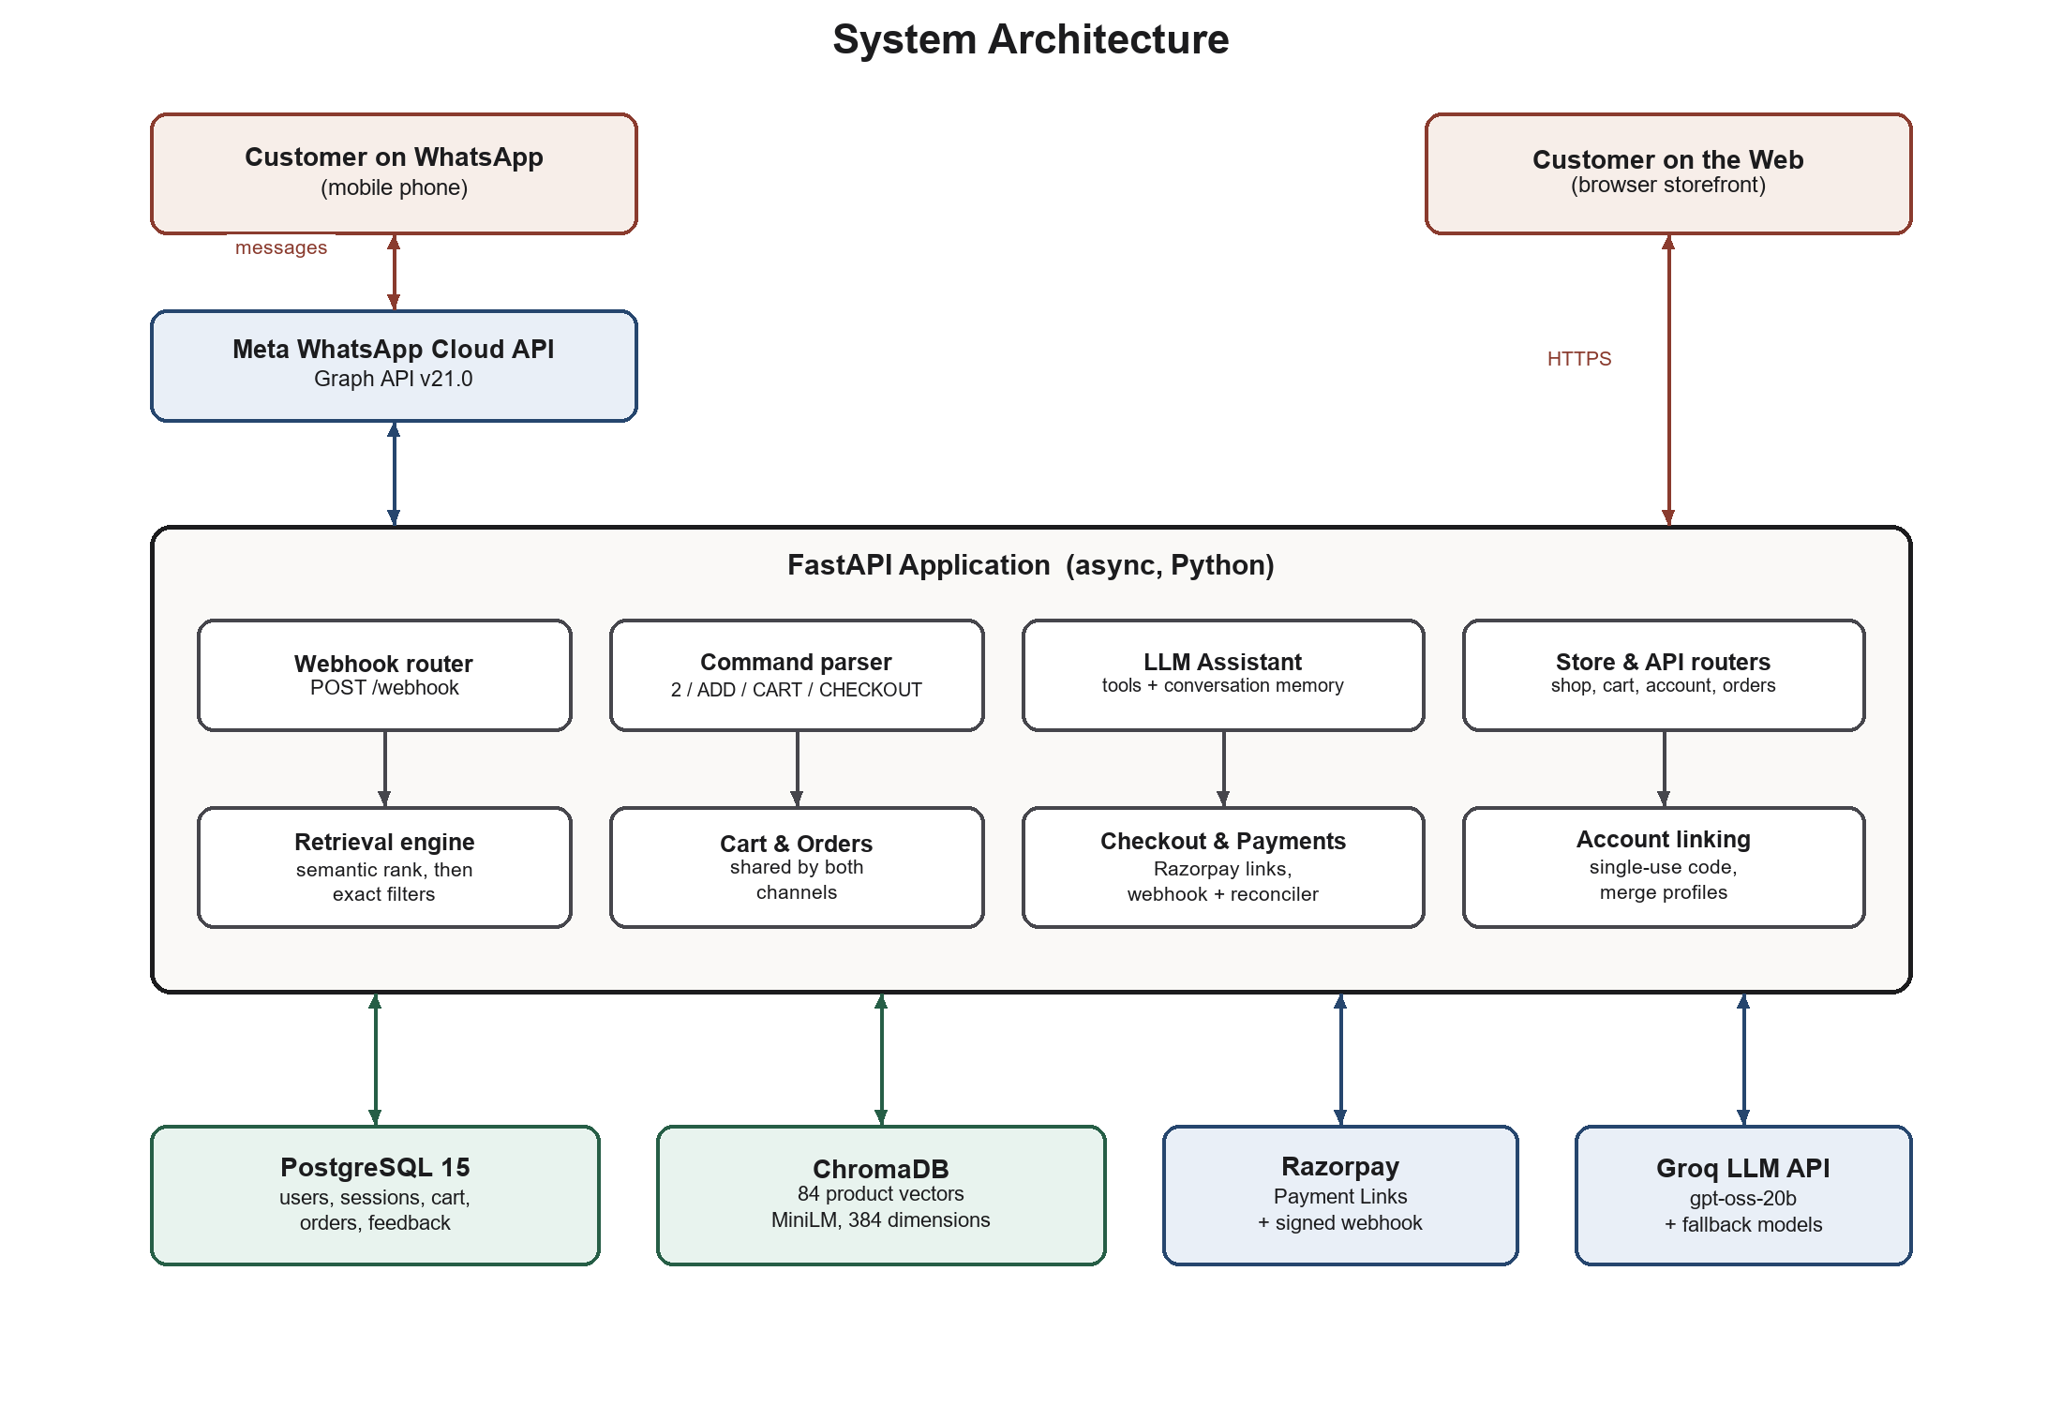
Figure 1: System architecture

5.3 Process Description
Step 1: Catalogue ingestion. Each product (32 fields: title, brand, price, MRP, fabric, colour, occasion tags, sizes and stock, and more) is converted into a descriptive text that carries occasion, fabric, colour and fit vocabulary. This text is embedded with the all-MiniLM-L6-v2 sentence-embedding model into a 384-dimensional vector and stored in ChromaDB. Price and stock are deliberately not embedded: they are filters, not meaning.
Step 2: Receiving a message. Meta delivers each incoming WhatsApp message to the POST /webhook endpoint. The server replies 200 OK immediately (otherwise Meta retries), ignores duplicate deliveries by message ID, and processes the message in a background task.
Step 3: Routing. Exact commands are handled directly by code, never by the language model: a number such as “2” (select from the last list), ADD, CART, REMOVE, CHECKOUT, BUY, ORDERS, HELP, product codes and account-link codes. The whole message must match a command pattern, so “2 piece kurta set” is still treated as a search.
Step 4: Conversational assistant. Free-text messages go to an LLM (served through the Groq API) with a fixed set of tools: search_products, get_product_details, get_my_orders, get_my_cart, add_to_cart, hide_product and send_reply. The model receives the last eight messages of the conversation, the customer's real cart and, for linked customers, their name and order history. It asks one or two clarifying questions if a request is vague and searches immediately if it is clear.
Step 5: Retrieval. The search tool embeds the query and ranks the whole catalogue by cosine similarity in ChromaDB. Hard constraints are then applied exactly in Python: gender, category (garment words such as “jacket” are mapped to real categories), budget and stock. Occasion words (haldi, garba, reception) move matching items to the top. If nothing passes, filters relax in a fixed order (budget, then category) and the reply says so. Queries with no meaningful match return nothing instead of random items.
Step 6: Grounded reply. Product lists, prices, photos, carts and order details are rendered by code from the database. The model's own text is checked: any rupee amount it writes must appear in the catalogue, the customer's message or a tool result, otherwise the model is asked to retry and the sentence is removed. Tools are bound to the sender's account, so the model cannot act for another user.
Step 7: Cart, checkout and payment. The cart is shared between WhatsApp and the website. CHECKOUT creates an order (with the delivery address snapshot) and a Razorpay Payment Link, sent as a “Pay Now” button. Payment is confirmed by two independent paths, either of which is enough: a signed Razorpay webhook (HMAC-SHA256 over the raw body) and a background reconciler that asks Razorpay about unpaid orders every few seconds. Marking an order paid is idempotent and row-locked, so the customer receives exactly one confirmation.
Step 8: Account linking. On the website's account page, a signed-in customer receives a single-use, 10-minute code and a wa.me link that pre-fills it in WhatsApp. When the code arrives from a phone number, that number is bound to the account. If that number already had a bot-created profile, its orders and conversations are merged into the website account in one database transaction.
Step 9: Owner training. Every free-text answer is logged. On the admin page, the owner rates products (✓/✕) for a question and rates whole replies (thumbs-up / thumbs-down, with an optional note). A ✓/✕ re-ranks that product for similar questions (cosine similarity ≥ 0.75); a thumbs-up reply becomes a few-shot example; a thumbs-down note becomes a rule in the prompt. No model weights change: the system changes what the model is shown.

5.4 Data Flow Diagram – Level 0 (Context Diagram)
The context diagram shows the system as a single process with the people and services that exchange data with it: the customer, the store owner, and the three external APIs.
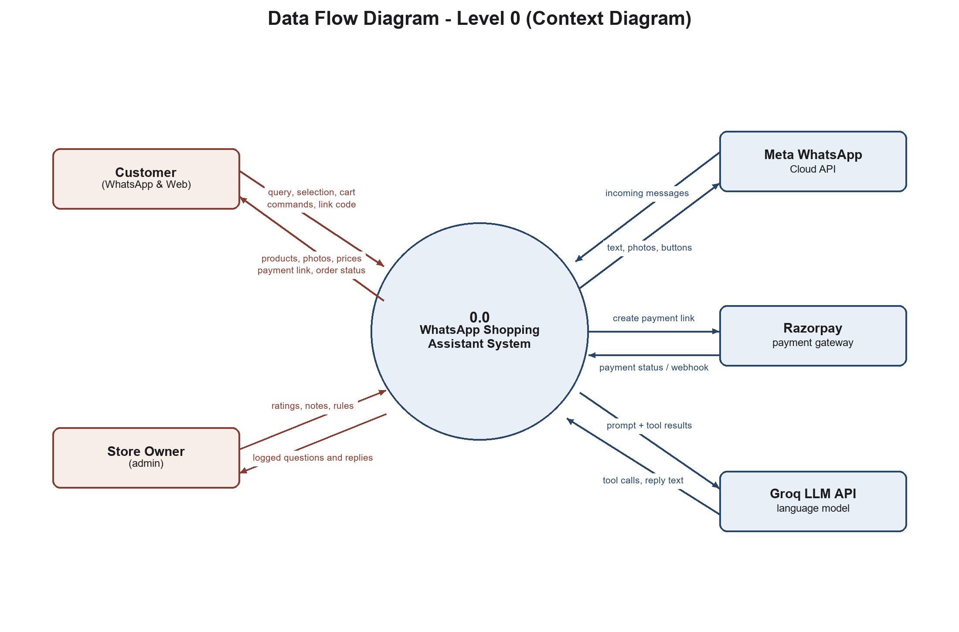
Figure 2: Data flow diagram – Level 0 (context diagram)

5.5 Data Flow Diagram – Level 1
Level 1 opens the system into seven processes and the data stores they read and write.
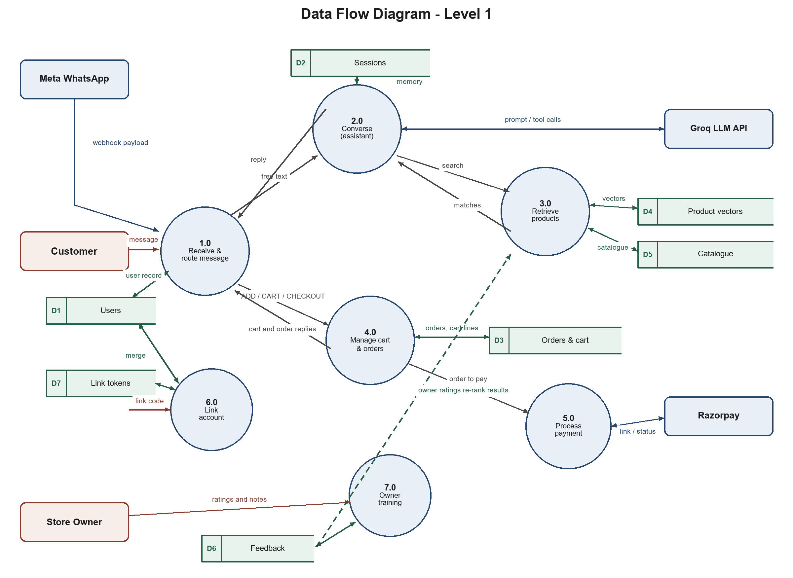
Figure 3: Data flow diagram – Level 1
Process | Input | Output | Data stores used
1.0 Receive and route message | Webhook payload from Meta | Command or free text to 2.0–6.0 | D2 Sessions (dedupe, context)
2.0 Converse (LLM assistant) | Free text, conversation memory, cart | Tool calls, checked reply | D2 Sessions, D6 Feedback
3.0 Retrieve products | Query, gender/category/budget | Ranked product list | D4 Product vectors, D5 Catalogue, D6 Feedback
4.0 Manage cart and orders | Selection, ADD/REMOVE/SIZE, CHECKOUT | Cart, order, address | D1 Users, D3 Cart and Orders
5.0 Process payment | Order; Razorpay webhook / status | Payment link, confirmation message | D3 Cart and Orders
6.0 Link account | Link code from WhatsApp | Bound account, merged history | D1 Users, D7 Link tokens
7.0 Owner training | Ratings and notes from admin page | Re-ranking, examples, rules | D6 Feedback and bot replies

Data stores: D1 Users · D2 Sessions (conversation memory, last products shown, selected item) · D3 Cart items, Orders and Order items · D4 ChromaDB product vectors · D5 Product catalogue (JSON) · D6 Bot replies and Feedback · D7 Link tokens.

5.6 Use Case Diagram
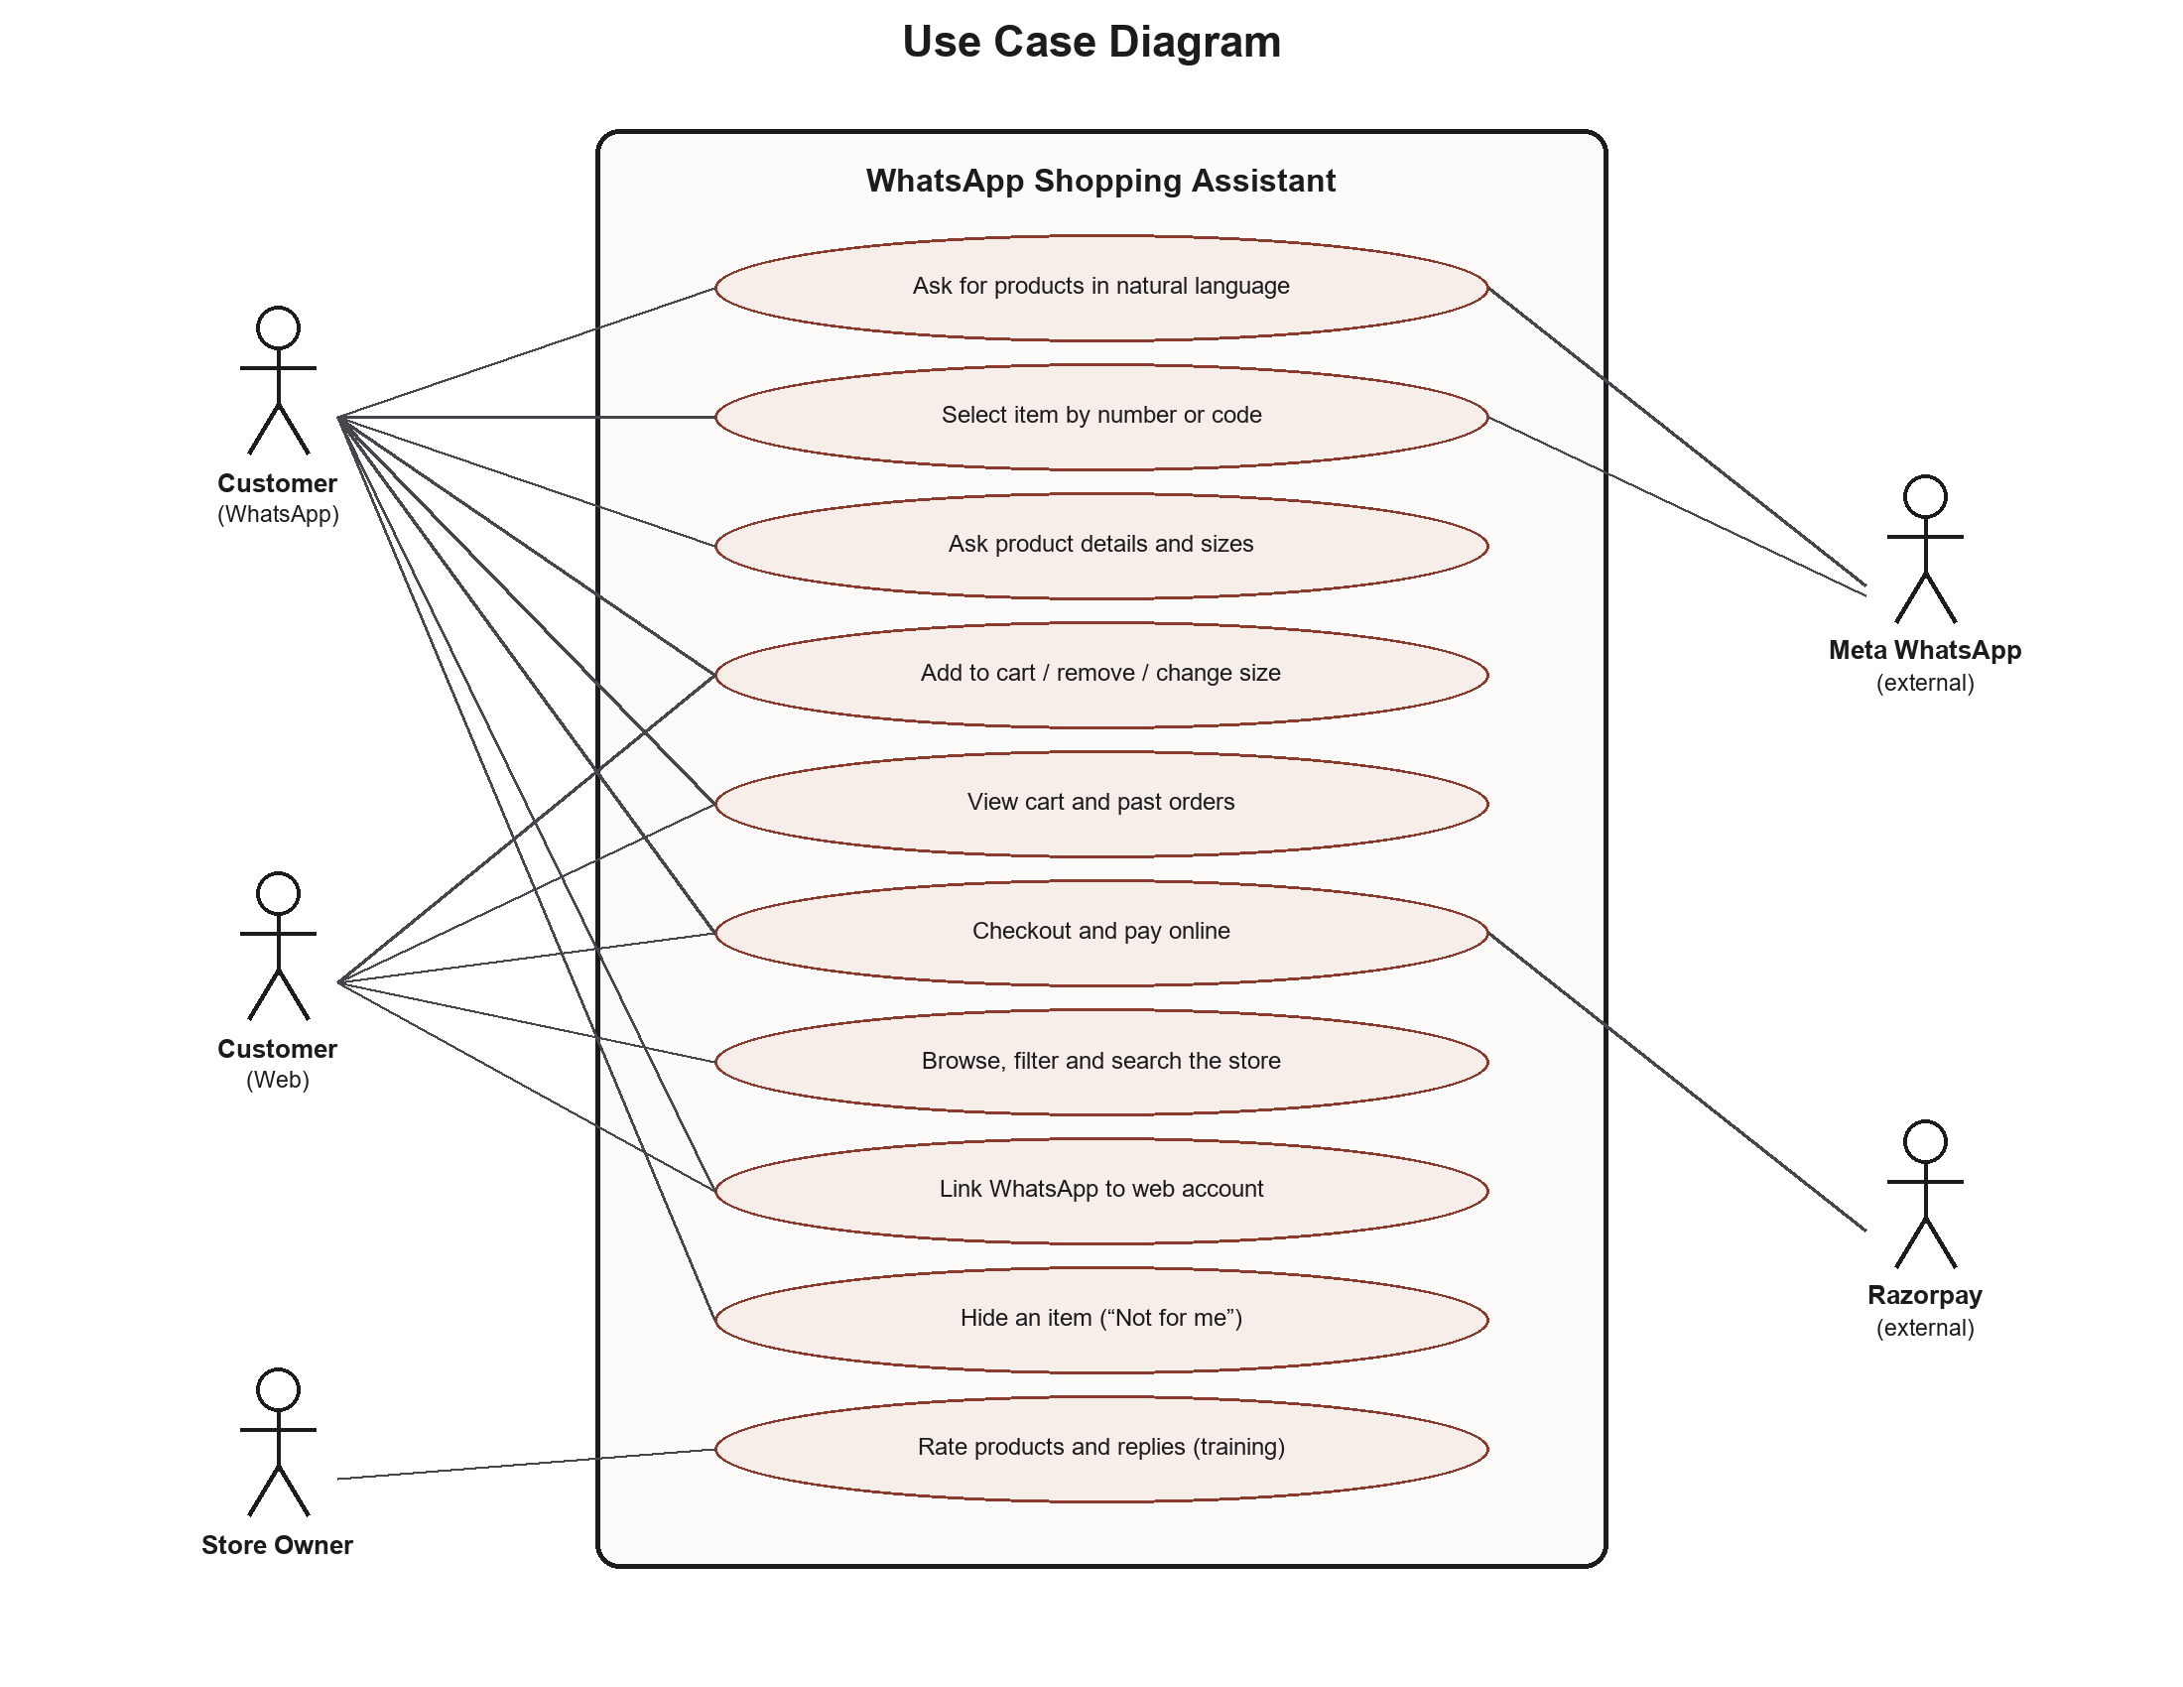
Figure 4: Use case diagram
Actor | Main use cases
Customer (WhatsApp) | Ask for products in natural language; pick one by number or code; ask about fabric, sizes or price; add to cart with size; view cart and orders; checkout and pay; hide items they dislike; link their web account
Customer (Web) | Sign up / log in; browse with filters and sort; semantic search; cart and checkout with delivery address; track orders; connect WhatsApp
Store Owner (Admin) | Review the assistant's conversations; rate products and replies; add rules; undo what it learned
Razorpay (external) | Create payment links; report payment status; send signed payment webhooks
Meta WhatsApp (external) | Deliver incoming messages; send outgoing text, images and buttons

5.7 Database Design (Summary)
Table | Purpose and key constraints
users | Web and/or WhatsApp identity. Check constraint: every user must have an email or a WhatsApp number.
sessions | Conversation state: last products shown, selected product, recent messages. Partial unique index allows one active session per user.
cart_items | One cart shared by both channels (product, size, quantity).
orders, order_items | Order header (status, amount, address snapshot, payment link) and lines. Product name and price are copied at purchase time, so an order records what was actually paid.
link_tokens | Single-use, time-limited codes for account linking.
bot_replies, feedback | Logged answers and owner/customer ratings with the question's embedding.

6. Hardware, Software and Technology Stack

6.1 Hardware Requirements
Item | Specification
Development machines | 2 laptops, 64-bit, minimum 8 GB RAM, 4-core CPU, 10 GB free disk. No GPU needed: the embedding model runs on CPU.
Test phones | Android or iOS smartphone with WhatsApp, registered as a test recipient
Network | Broadband internet for the WhatsApp, Razorpay and LLM APIs

6.2 Software and Technology Stack
Layer | Technology | Reason for choice
Language | Python 3 | Mature AI and web ecosystem
Web framework | FastAPI, Uvicorn | Asynchronous; suits a webhook that calls several services and must reply quickly
HTTP client | httpx (async) | Non-blocking calls to WhatsApp, Razorpay and the LLM
Database | PostgreSQL 15, SQLModel / SQLAlchemy | Transactions, constraints and row locking for orders and payments
Vector database | ChromaDB (persistent) | Local, free, no account needed; HNSW approximate nearest-neighbour search
Embedding model | all-MiniLM-L6-v2 (sentence-transformers), 384 dimensions | Free, runs offline on CPU, cannot be rate-limited during a demo. OpenAI text-embedding-3-small is supported as an option.
Language model | gpt-oss-20b via Groq API (OpenAI-compatible), with fallback models | Fast tool calling on a free tier; automatic fallback on rate limits
Messaging | WhatsApp Cloud API (Graph API v21.0) | Official API: text, images, interactive buttons, media upload
Payments | Razorpay Payment Links (test mode) and webhooks | One link works for both chat and web; UPI, cards and netbanking
Front end | Jinja2 templates, Tailwind CSS 3.4 (compiled), vanilla JavaScript | Server-rendered pages that work offline at the venue; live sync by polling
Security | bcrypt, itsdangerous signed sessions, HMAC-SHA256 | Password hashing, session cookies, webhook signature verification
Infrastructure | Docker Compose, ngrok | Identical Postgres and Chroma on both machines; public HTTPS URL for Meta's webhook
Tools | Git and GitHub, VS Code, Meta Developer dashboard, Razorpay dashboard | Version control and API configuration

7. Contribution towards Society
- Empowers small businesses. Local boutiques and small sellers already sell over WhatsApp by hand. This system gives them an always-available assistant that answers questions, shows photos and collects payment, a capability usually only large e-commerce companies can afford. This supports livelihoods and local commerce.
- Accessible to less tech-savvy users. Many people, including older and first-time internet users, are comfortable with WhatsApp but find e-commerce websites and apps confusing. Shopping by typing a sentence or a number lowers this barrier. No new app, password or form is required to start.
- Promotes digital payments. Secure payment links (UPI, cards) inside the chat replace sharing bank details over messages or relying on cash on delivery.
- Responsible use of AI. The design shows how to use a language model safely where money is involved: facts are checked in code, the model cannot act for another user, and prices it cannot justify are removed. This pattern applies to other public-facing AI systems too.
- Less waste from failed deliveries. Clear product information, size selection and confirmed orders reduce wrong purchases and returned parcels, which cost money and fuel.
- Alignment with Sustainable Development Goals: SDG 8 (Decent Work and Economic Growth), by strengthening small enterprises, and SDG 9 (Industry, Innovation and Infrastructure), by making digital commerce infrastructure accessible.

8. Schedule of the Project (PERT Chart)
The project was executed as a seven-day sprint from 17 to 23 September 2026. The PERT chart below shows the eleven tasks, the order in which they had to happen, and the longest chain of dependent tasks — the critical path — which determined the total duration.
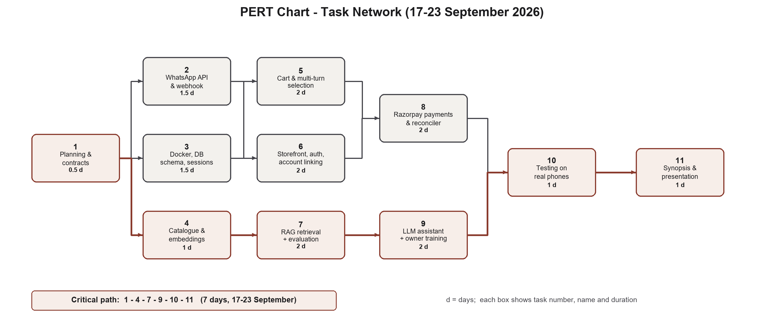
Figure 5: PERT chart of project tasks; the shaded chain is the critical path
Task | Owner | Depends on | Duration | Dates
1. Planning, architecture, work split and contracts | Both | — | 0.5 d | 17 Sep
2. WhatsApp Cloud API, webhook verification, messaging | A | 1 | 1.5 d | 17–18 Sep
3. Docker Compose, database schema, sessions | A | 1 | 1.5 d | 18–19 Sep
4. Catalogue design and embedding ingestion | B | 1 | 1 d | 18 Sep
5. Cart and multi-turn selection | A | 2, 3 | 2 d | 19–20 Sep
6. Storefront, authentication, account linking | A | 3 | 2 d | 19–21 Sep
7. RAG retrieval and evaluation (46 cases) | B | 4 | 2 d | 19–21 Sep
8. Razorpay payments, webhook and reconciler | A | 5, 6 | 2 d | 20–21 Sep
9. LLM assistant, memory and owner training | B | 7 | 2 d | 21–22 Sep
10. Testing on real phones and bug fixing | Both | 8, 9 | 1 d | 22–23 Sep
11. Documentation, synopsis and presentation | Both | 10 | 1 d | 22–23 Sep

A = Buying half (backend, payments, storefront); B = Finding half (retrieval, assistant). Critical path: 1 → 4 → 7 → 9 → 10 → 11.

9. Implementation / Prototype Status
A working prototype is complete and has been tested end-to-end on a real phone, including a real test-mode payment. The main implemented features are:

9.1 WhatsApp Assistant
- Natural-language product search with photo replies: each product is sent as an image with a caption (name, price, MRP, one-line description, link). Images are uploaded once to WhatsApp's media API and the media ID is cached.
- Clarifying questions for vague requests, immediate search for clear ones, and memory of the last 12 messages.
- Follow-ups resolved from context: “2”, “the second one”, “add this one to cart”, “size M”, or a product code such as EW006.
- Commands: ADD, CART, REMOVE n, SIZE n x, CHECKOUT, BUY, ORDERS, HELP; greetings are answered without running a search.
- Personalised greetings and suggestions for linked customers, based on their order history.
- “Not for me” button under each photo, which hides that item for that customer only.
- Resilience: automatic fallback between LLM models on rate limits, repair of malformed tool calls, and a plain search fallback if the LLM is unavailable.

9.2 Web Storefront
- Home, shop (filters by category, gender, function, price; sorting), product pages with “You may also like”, and semantic site search using the same engine as the bot.
- Sign-up/login, account page, cart, checkout with validated delivery address (10-digit mobile, 6-digit PIN), order tracking page (placed, paid, arriving by).
- Live sync: when the customer changes their cart on WhatsApp, the open website updates within about two seconds.
- “Ask about this on WhatsApp” button that opens the chat with the product code pre-filled.

9.3 Payments
- Razorpay Payment Links for both channels, delivered in chat as a “Pay Now” button.
- Confirmation by signed webhook and by a background reconciler; idempotent, row-locked update, so exactly one WhatsApp confirmation is sent.
- Web orders placed by a linked customer are also confirmed on their WhatsApp.

9.4 Owner Training (Admin)
- Admin page showing each conversation, where the owner can rate products and replies and add notes, with a list of everything learned and an Undo option.

9.5 Testing and Evaluation
Test suite | What it verifies | Result
Retrieval evaluation | 46 realistic phrasings (for example, “groom outfit”, “bag to match a lehenga”, “me and my wife for a sangeet”); every result must satisfy gender, category, and budget, plus every owner rating | 46 / 46 pass
Assistant tests | Tool use, memory, price checking, trust boundaries, using a scripted fake model (no API quota) | 55 checks pass
Account linking tests | Single-use codes, expiry, merge of bot-created profile into web account | 18 checks pass
Training tests | Re-ranking by similar questions, examples, rules, undo | 28 checks pass
Payment, cart, store and live-sync tests | Checkout, webhook signature, duplicate confirmation, cart sync, polling logic | All pass

For comparison, the first simple RAG version scored 8/10 on an easier 10-case set. The rebuilt retrieval, which applies hard constraints after semantic ranking, now passes all 46 harder cases.

9.6 Sample Interaction
Customer | Assistant
hi | Greeting, with a short guide to what the assistant can do
need a sherwani for my wedding under 10000 | Three matching sherwanis, each as a photo with price and code
the second one, what fabric is it? | Fabric, fit and available sizes of item 2, from the catalogue
add it in size L | Added to cart; current cart and total (computed by code)
CHECKOUT | Order summary with a “Pay Now” button (Razorpay)
(customer pays) | Payment confirmation and expected delivery date

10. Resources and Limitations

10.1 Resources Required
- Accounts and APIs: Meta Developer account with a WhatsApp Business test number; Razorpay test account; Groq API key (free tier).
- Data: a product catalogue of 84 items with 32 fields each. Brand names and product data are fabricated for the project. Product photos are royalty-free images from Pexels, stored locally with credits.
- Hardware and software: as listed in Section 6. All software used is free or open source.

10.2 Limitations
- WhatsApp test number: it can only message recipients added in the Meta dashboard. Free-form replies are allowed only within 24 hours of the customer's last message, and the temporary access token expires about every 24 hours.
- Single store: credentials and catalogue are configured for one store. Serving many stores needs multi-tenant data separation.
- Domain-specific rules: some retrieval rules (garment-to-category mapping, occasion words) are written for Indian ethnic wear and would need to be generalised for other product types.
- LLM rate limits: the free tier allows about 8,000 tokens per minute per model, so rapid messages can slow replies. Fallback models reduce but do not remove this.
- Language: English and simple Hinglish only; no voice notes or image search.
- Payments in test mode: no real money moves; going live requires Razorpay KYC and a verified WhatsApp business number.
- No schema migrations: schema changes currently require recreating tables, which is acceptable only while data is disposable.
- Development tunnel: the webhook is exposed through ngrok for development rather than a permanent deployment.

11. Conclusion
This project delivers a working conversational shopping system in which a customer can go from “I need something for a sangeet” to a paid order without leaving WhatsApp, while the store's website stays in step. Its main innovations are:
- Grounded AI with code-enforced trust boundaries: the language model chooses what to do, but products, prices, carts and totals are always produced by code, and any unjustified price the model writes is removed.
- Hybrid retrieval: semantic ranking over the whole catalogue followed by exact filters and controlled relaxation, which passes 46 of 46 evaluation cases where pure embedding search failed on basic constraints.
- Secure identity bridge between WhatsApp and the web: single-use deep-link codes, with automatic merging of earlier chat history.
- Reliable payments: two independent confirmation paths with an idempotent, row-locked update, so every payment is confirmed exactly once.
- Training without fine-tuning: the store owner improves the assistant through ratings that change ranking, examples and rules, with full undo.
- One engine, two channels: the bot and the website share the same search, cart and orders, and stay synchronised live.
The architecture extends naturally to multiple stores, platform integrations such as Shopify, and features such as abandoned-cart reminders and order confirmation for cash-on-delivery, giving the project a clear path from an academic prototype to a practical product for small businesses.

12. References
[1] P. Lewis, E. Perez, A. Piktus, F. Petroni, V. Karpukhin, N. Goyal, et al., “Retrieval-augmented generation for knowledge-intensive NLP tasks,” in Proc. Advances in Neural Information Processing Systems (NeurIPS), vol. 33, 2020, pp. 9459–9474.
[2] N. Reimers and I. Gurevych, “Sentence-BERT: Sentence embeddings using Siamese BERT-networks,” in Proc. EMNLP-IJCNLP, Hong Kong, 2019, pp. 3982–3992.
[3] W. Wang, F. Wei, L. Dong, H. Bao, N. Yang, and M. Zhou, “MiniLM: Deep self-attention distillation for task-agnostic compression of pre-trained transformers,” in Proc. NeurIPS, vol. 33, 2020.
[4] Y. A. Malkov and D. A. Yashunin, “Efficient and robust approximate nearest neighbor search using hierarchical navigable small world graphs,” IEEE Trans. Pattern Anal. Mach. Intell., vol. 42, no. 4, pp. 824–836, Apr. 2020.
[5] S. Yao, J. Zhao, D. Yu, N. Du, I. Shafran, K. Narasimhan, and Y. Cao, “ReAct: Synergizing reasoning and acting in language models,” in Proc. Int. Conf. Learning Representations (ICLR), 2023.
[6] T. Schick, J. Dwivedi-Yu, R. Dessì, R. Raileanu, M. Lomeli, L. Zettlemoyer, N. Cancedda, and T. Scialom, “Toolformer: Language models can teach themselves to use tools,” in Proc. NeurIPS, 2023.
[7] T. Brown, B. Mann, N. Ryder, M. Subbiah, et al., “Language models are few-shot learners,” in Proc. NeurIPS, vol. 33, 2020, pp. 1877–1901.
[8] Z. Ji, N. Lee, R. Frieske, T. Yu, D. Su, Y. Xu, et al., “Survey of hallucination in natural language generation,” ACM Computing Surveys, vol. 55, no. 12, pp. 1–38, 2023.
[9] R. S. Pressman and B. R. Maxim, Software Engineering: A Practitioner's Approach, 8th ed. New York, NY, USA: McGraw-Hill Education, 2015.
[10] Meta Platforms. WhatsApp Cloud API documentation. [Online]. Available: https://developers.facebook.com/docs/whatsapp/cloud-api
[11] Razorpay. Payment Links documentation. [Online]. Available: https://razorpay.com/docs/payments/payment-links/
[12] Razorpay. Webhooks: validate and test. [Online]. Available: https://razorpay.com/docs/webhooks/
[13] S. Ramírez. FastAPI documentation. [Online]. Available: https://fastapi.tiangolo.com/
[14] Chroma. ChromaDB documentation. [Online]. Available: https://docs.trychroma.com/
[15] Hugging Face. sentence-transformers/all-MiniLM-L6-v2 model card. [Online]. Available: https://huggingface.co/sentence-transformers/all-MiniLM-L6-v2
[16] Groq. GroqCloud API documentation. [Online]. Available: https://console.groq.com/docs
[17] OpenAI. Introducing gpt-oss. [Online]. Available: https://openai.com/index/introducing-gpt-oss/
[18] The PostgreSQL Global Development Group. PostgreSQL 15 documentation. [Online]. Available: https://www.postgresql.org/docs/15/
[19] S. Ramírez. SQLModel documentation. [Online]. Available: https://sqlmodel.tiangolo.com/
[20] Tailwind Labs. Tailwind CSS v3 documentation. [Online]. Available: https://v3.tailwindcss.com/docs
[21] Docker Inc. Docker Compose documentation. [Online]. Available: https://docs.docker.com/compose/
[22] United Nations. The 17 Sustainable Development Goals. [Online]. Available: https://sdgs.un.org/goals

